* Resistance:
  + With 1M resistor:

(array([-14.39626433, 0.86200157]), array([[ 0.05480121, -0.01264975],

[-0.01264975, 0.00361457]]))

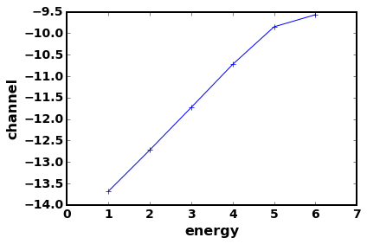



* Exclude 1M resistor:

(array([-14.6370452 , 0.96518107]), array([[ 0.00160442, -0.00043748], [-0.00043748, 0.00014581]])) 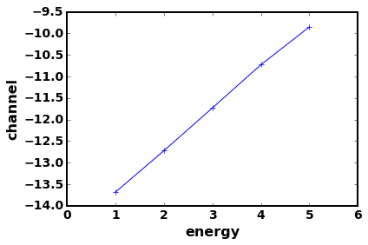



* Bandwidth, 10k resistor, equivalent bandwidth.

(array([-16.29078748, 1.10988894]), array([[ 0.00321807, -0.0007651 ],

[-0.0007651 , 0.00018752]]))

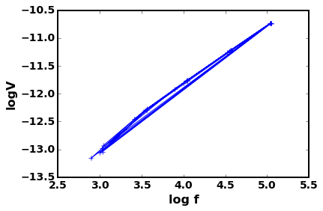



* Bandwidth,100k resistor, equivalent bandwidth.

(array([-14.85023855, 1.00418547]), array([[ 0.00159692, -0.00039571],

[-0.00039571, 0.00010348]]))

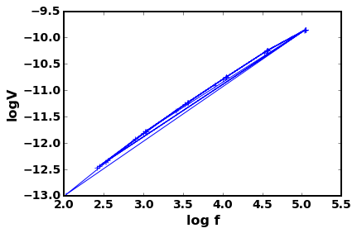

* Bandwidth, 10k, |f2-f1|

(array([-16.00618999, 1.05665815]), array([[ 0.0110819 , -0.00266691],

[-0.00266691, 0.00066411]]))

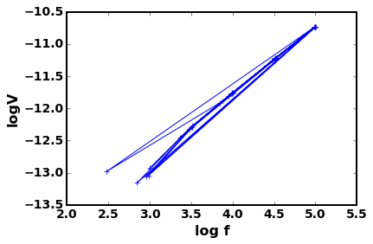

* Bandwidth, 100k, |f2-f1|

(array([-14.5242404 , 0.93897072]), array([[ 0.00552822, -0.00137508],

[-0.00137508, 0.0003628 ]])) 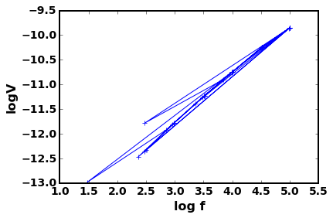

* Bandwidth100k,boltzman
* (array([ -5.03035009e-14, 1.49565706e-15]), array([[ 9.85058210e-29, -1.26819684e-31],
* [ -1.26819684e-31, 7.48180152e-34]])) 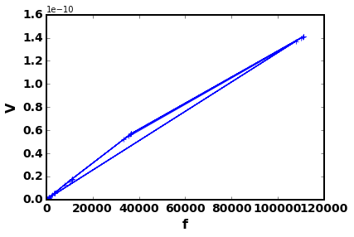
* T,10k,1k-10k
* (array([-14.31011276, 1.01845573]), array([[ 0.00073411, -0.00031444],
* [-0.00031444, 0.00013688]])) 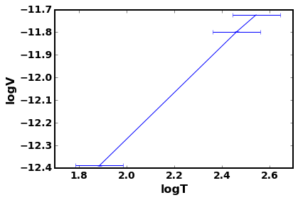
* T,10k,1k-33k
* (array([-13.68216906, 0.98055048]), array([[ 1.81421315e-05, -7.76662739e-06],
* [ -7.76662739e-06, 3.37872429e-06]]))
* 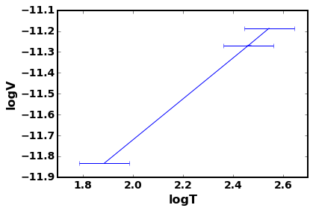
* T,10k,1k-100k
* (array([-13.16685811, 0.93113234]), array([[ 2.86598231e-05, -1.22667666e-05],
* [ -1.22667666e-05, 5.33584000e-06]])) 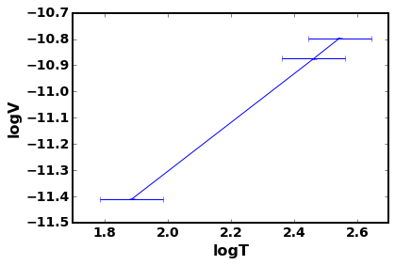
* T,10k,0.1k-10k
* (array([-14.19523403, 0.98904813]), array([[ 8.02714361e-06, -3.43986361e-06],
* [ -3.43986361e-06, 1.49806726e-06]]))
* 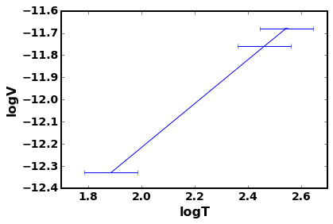
* T,10k,0.1k-33k
* (array([-13.64434996, 0.96976337]), array([[ 9.38976739e-05, -4.02148419e-05],
* [ -4.02148419e-05, 1.75037916e-05]]))
* 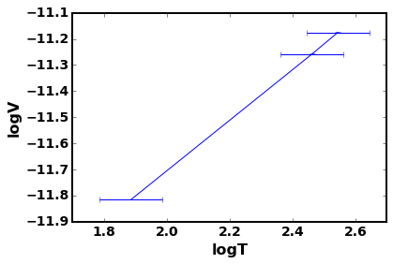
* T,10k,0.1k-100k
* (array([-13.17436565, 0.93560736]), array([[ 4.93587827e-05, -2.11390417e-05],
* [ -2.11390417e-05, 9.20029925e-06]])) 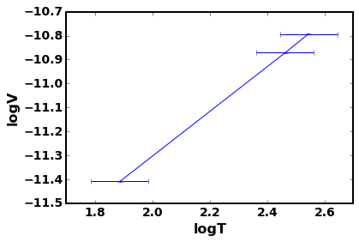
* T,100k,1k-10k
* (array([-13.3177891 , 0.96444492]), array([[ 9.21509949e-05, -3.94689490e-05],
* [ -3.94689490e-05, 1.71780251e-05]]))
* 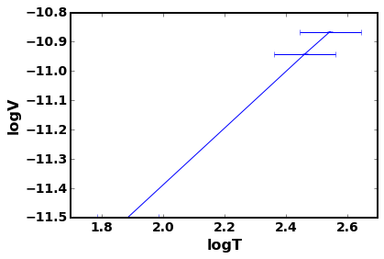
* T,100k,1k-33k
* (array([-12.90234477, 0.90402457]), array([[ 2.34732886e-06, -1.00490460e-06],
* [ -1.00490460e-06, 4.37155544e-07]]))
* 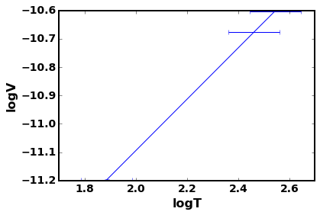
* T,100k,1k-100k
* (array([-12.6504206 , 0.84616108]), array([[ 5.42018755e-07, -2.32098152e-07],
* [ -2.32098152e-07, 1.00997953e-07]])) 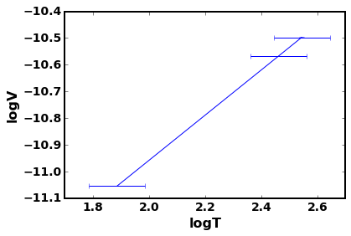
* T,100k,0.1k-10k
* (array([-13.27113943, 0.96861414]), array([[ 3.36470886e-05, -1.44146991e-05],
* [ -1.44146991e-05, 6.27589242e-06]]))
* 